ON TEST TM (Recursive T - Decidable)
It makes multiple passes over the input string with the read-write head. On each pass it matches one of the characters on each side of the # symbol.

To keep track of which symbols have been checked already, M₁ crosses off each symbol as it is examined.

If it crosses off all the symbols, that means that everything matched successfully, and M₁ goes into an accept state. If it discovers a mismatch, it enters a reject state.

In summary, M₁'s algorithm is as follows.

M₁ = "On input string w:

1. Scan the input to be sure that it contains a single # symbol. If not, reject.

2. Zig-zag across the tape to corresponding positions on either side of the # symbol to check on whether these positions contain the same symbol. If they do not, reject. Cross off symbols as they are checked to keep track of which symbols correspond.

3. When all symbols to the left of the # have been crossed off, check for any remaining symbols to the right of the #.

If any symbols remain, reject; otherwise accept."

The following figure contains several snapshots of M₁'s tape while it is computing in stages 2 and 3 when started on input 011000#011000.

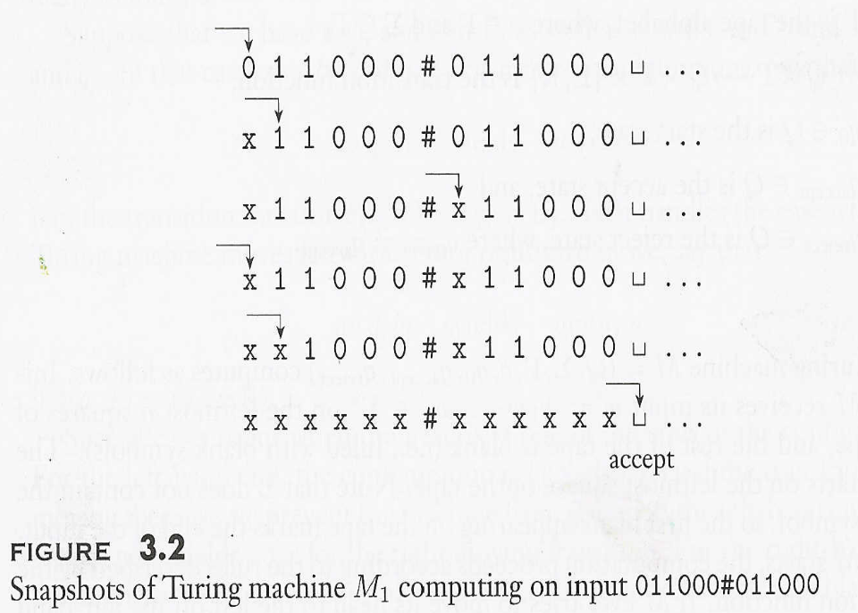

This description of Turing machine M₁ sketches the way it functions but does not give all its details.

We can describe Turing machines in complete detail by giving formal descriptions analogous to those introduced for finite and pushdown automata.

The formal description specifies each of the parts of the formal definition of the Turing machine model to be presented shortly.

In actuality, we almost never give formal descriptions of Turing machines because they tend to be very big.

FORMAL DEFINITION OF A TURING MACHINE

The heart of the definition of a Turing machine is the transition function δ because it tells us how the machine gets from one step to the next.

For a Turing machine, δ takes the form:

Q x Γ → Q x Γ x {L, R}

That is, when the machine is in a certain state q and the head is over a tape square containing a symbol a, and if δ (q, a) = (r, b, L), the machine writes the symbol b replacing the a, and goes to state r.

The third component is either L or R and indicates whether the head moves to the left or right after writing. In this case, the L indicates a move to the left.

DEFINITION 3.1
A Turing machine is a 7-tuple, (Q, Σ, Γ, δ, q₀, q_{accept} , q_{reject}), where Q, Σ, Γ are all finite sets and

1. Q is the set of states,
2. Σ is the input alphabet not containing the special blank symbol ⊥ ,
3. Γ is the tape alphabet, where ⊥ ∈ Γand Σ ⊆ Γ,
4. δ: Q x Γ → Q x Γ x {L, R} is the transition function,
5. q₀ ∈ Q is the start state,
6. q_{accept} ∈ Q is the accept state, and
7. q_{reject} ∈ Q is the reject state, where q_{reject} ≠ q_{accept}.

Note:
Some textbooks define the Turing Machine as a 5-tuple leaving out the accept and reject states. Others, includes a halt state as the accept state and if this state is not reached the machine automatically rejects.

EXAMPLES OF TURING MACHINES (ON TEST)

As we did for finite and pushdown automata, we can give a formal description of a particular Turing machine by specifying each of its seven parts in detail.

However, going to that level of detail for Turing machines can be cumbersome for all but the tiniest machines.

Accordingly, we won't spend much time giving such descriptions.

Mostly, we will give only high-level descriptions because they are precise enough for our purposes and are much easier to understand.

Nevertheless, it is important to remember that every high-level description (we can call it a hand-waving descripyion) is actually just shorthand for its formal counterpart.

With patience and care we could describe any of the Turing machines in this book in complete formal detail.

To help you make the connection between the formal descriptions and the high-level descriptions, (hand=waving), we give state diagrams in the next two examples.

Here we describe a TM M₂ that recognizes the language consisting of all strings of 0's whose length is a power of 2.

It decides the language A = {0^{m}| m = 2^{n} and n ≥ 0}.

M₂ = "On input string w:

1. Sweep left to right across the tape, crossing off every other 0.

2. If in stage 1 the tape contained a single 0, accept.

3. If in stage 1 the tape contained more than a single 0 and the number of 0s was odd, reject.

4. Return the head to the left-hand end of the tape.

5. Go to stage 1."

Each iteration of stage 1 cuts the number of 0s in half.

As the machine sweeps across the tape in stage 1, it keeps track of whether the number of 0s seen is even or odd.

If that number is odd and greater than 1, the original number of 0s in the input could not have been a power of 2. Therefore, the machine rejects in this instance.

However, if the number of 0s seen is 1, the original number must have been a power of 2. So, in this case the machine accepts.

Now we give the formal description of M₂ = (Q, Σ, Γ, δ, q₁, q_{accept}, q_{reject}).

1 Q = {q₁, q₂, q₃, q₄, q₅, q_{accept}, q_{reject}},
2 Σ = {0}, and
3 Γ = {0, x, ⊥}.
4 We describe δ with a state diagram (see Figure 3.4).
5 The start, accept, and reject states are q₁, q_{accept}, and q_{reject}.

In the state diagram in Fig. 3. 4 the label 0 → ⊥, R appears on the transition from q₁ to q₂.

It signifies that, when in state q₁ with the head reading 0, the machine goes to state q₂, writes ⊥, and moves the head to the right. In other words,

δ(q₁, 0) = (q₂, ⊥, R)

For clarity, we use the shorthand 0 → R in the transition from q₃ to q₄, as meaning that the machine moves to the right when reading 0 in state q₃ but doesn't alter the tape, so

δ(q₃, 0) = (q₄, 0, R)

This machine begins by writing a blank symbol over the leftmost 0 on the tape so that it can find the left-hand end of the tape in stage 4.

Whereas we would normally use a more suggestive symbol such as # for the left-hand end delimiter, we use a blank here to keep the tape alphabet, and hence the state diagram, small.

Example 3.6 gives another method of finding the left-hand end of the tape.

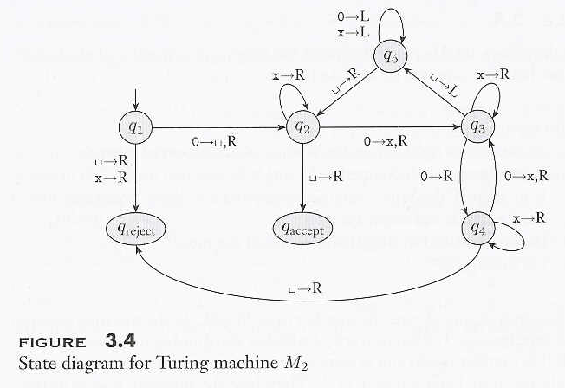

We give a sample run of this machine on input 0000. The starting configuration is q₁0000.
The sequence of configurations the machine enters appears following Figure 3.4. Read down the columns and left to right.

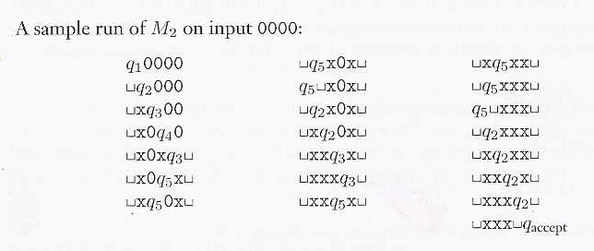
An alternate way of describing this TM is by listing its δ transitions as shown below.

δ(q₁, 0) = (q₂, ⊥, R)
δ(q₂, 0) = (q₃, x, R)
δ(q₃, 0) = (q₄, 0, R)
δ(q₄, 0) = (q₃, x, R)
δ(q₃, ⊥) = (q₅, ⊥, L)
δ(q₅, x) = (q₅, x, L)
δ(q₅, 0) = (q₅, 0, L)
δ(q₅, x) = (q₅, x, L)
δ(q₅, ⊥) = (q₂, ⊥, R)
δ(q₂, x) = (q₂, x, R)
δ(q₂, 0) = (q₃, x, R)
δ(q₃, x) = (q₃, x, R)
δ(q₂, ⊥) = (q_{accept}, ⊥, R)

EXAMPLE 3.6 (ON TEST)

Here, a Turing machine M₃ is doing some elementary arithmetic. It decides the language C = {a^{i}b^{j}c^{k}| i x j = k and i, j, k ≥ 1}.

M₃ = "On input string w:

1. Scan the input from left to right to be sure that it is a member of a⁺b⁺c⁺ and reject if it isn't.
2. Return the head to the left-hand end of the tape.
3. Cross off an a and scan to the right until a b occurs. Shuttle between the b's and the c's, crossing off one of each until all b's are gone.
4. Restore the crossed off b's and repeat stage 3 if there is another a to cross off. If all a's are crossed off, check on whether all c's also are crossed off. If yes, accept; otherwise, reject."

Let's examine the four stages of M₃ more closely.

In stage 1 the machine operates like a finite automaton. No writing is necessary as the head moves from left to right, keeping track using its states of whether the input is in the proper form.

Stage 2 looks equally simple but contains a subtlety. How can the Turing machine find the left-hand end of the input tape? Finding the right-hand end of the input is easy because it is terminated with a blank symbol. But the left-hand end has no terminator initially.

One technique that allows the machine to find the left-hand end of the tape is for it to mark the leftmost symbol in some way when the machine starts with its head on that symbol. Then the machine may scan left until it finds the mark when it wants to reset its head to the left-hand end.

Example 3.4 illustrated this technique, using a blank symbol to mark the left-hand tape symbol.

A trickier method of finding the left-hand end of the tape takes advantage of the way that we defined the Turing machine model.

Recall that, if the machine tries to move its head beyond the left-hand end of the tape, it stays in the same place.

We can use this feature to make a left-hand end detector.

To detect whether the head is sitting on the left-hand end the machine can write a special symbol over the current position, while recording the symbol that it replaced in the control.

Then it can attempt to move the head to the left.

If it is still over the special symbol, the leftward move didn't succeed, and thus the head must have been at the left-hand end.

If instead it is over a different symbol, some symbols remained to the left of that position on the tape. Before going farther, the machine must be sure to restore the changed symbol to the original. Stages 3 and 4 have straightforward implementations using several states each.

